Charles M. Blow
Black Dads Are Doing Best of All

Charles M. Blow (b. 1970) is a columnist for the New York Times, where the following piece appeared. He has served at the Times as graphics editor, graphics director, and design director for news, and he is the author of the memoir Fire Shut Up in My Bones. The sources that Blow refers to have been adapted to illustrate the MLA (Modern Language Association) documentation style.

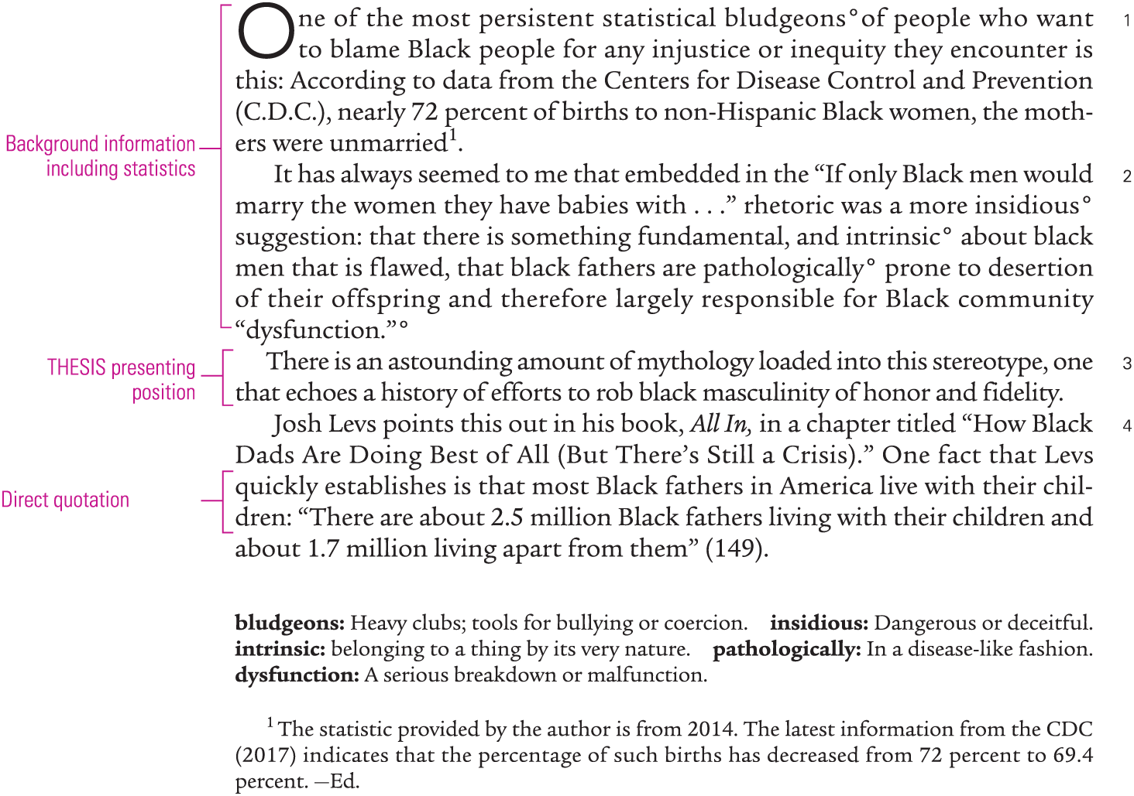

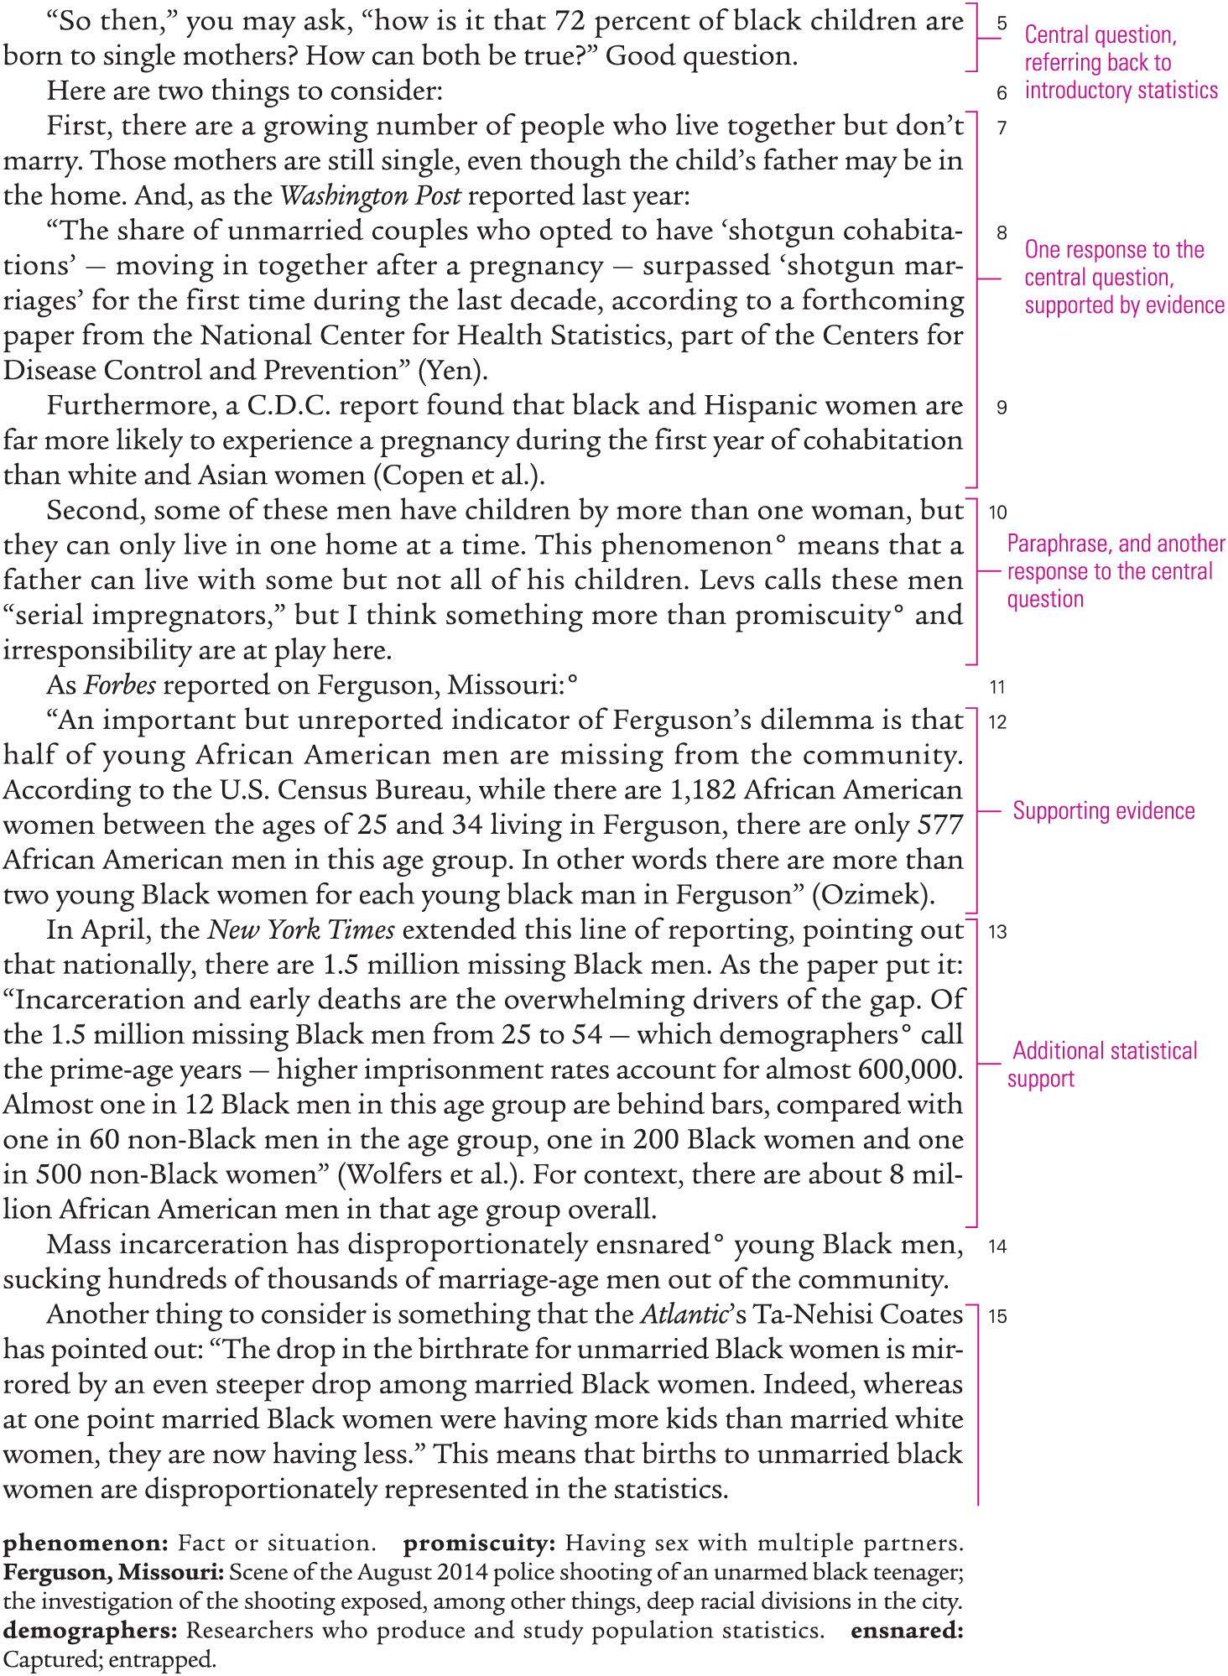
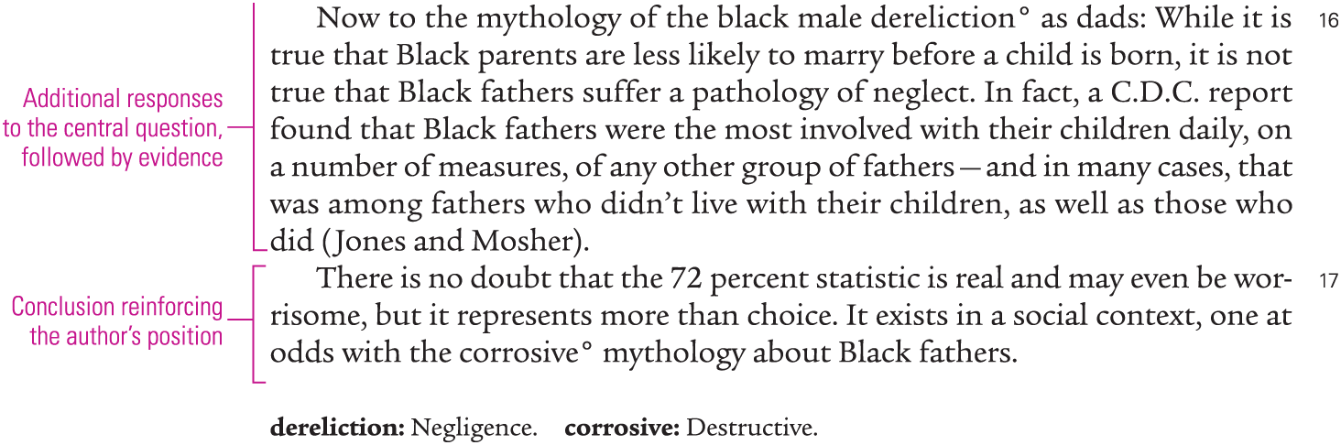

Works Cited
Each source cited in Blow’s essay listed alphabetically by author, with full publication information
First line of entry placed at left margin, with subsequent lines indented ½ inch
- Coates, Ta-Nehisi. “Understanding Out-of-Wedlock Births in Black America.” The Atlantic, 21 June 2013, theatlantic.com/sexes/archive/2013/06/understanding-out-of-wedlock-births-in-black-america/277084/.
- Copen, Casey E., et al. “First Premarital Cohabitation in the United States: 2006–2010 National Survey of Family Growth.” National Health Statistics Reports, no. 64, National Center for Health Statistics, 4 Apr. 2013, cdc.gov/nchs/data/nhsr/nhsr064.pdf.
- Jones, Jo, and William D. Mosher. “Fathers’ Involvement with Their Children: United States, 2006–2010.” National Health Statistics Reports, no. 71, National Center for Health Statistics, 20 Dec. 2013, cdc.gov/nchs/data/nhsr/nhsr071.pdf.
- Levs, Josh. All In: How Our Work-First Culture Fails Dads, Families, and Businesses—And How We Can Fix It Together. HarperCollins, 2015.
- Ozimek, Adam. “Half of Ferguson’s Young African American Men Are Missing.” Forbes, 18 Mar. 2015, forbes.com/sites/modeledbehavior/2015/03/18/half-of-fergusons-young-african-american-men-are-missing/#273f5c58119b.
- United States, Centers for Disease Control and Prevention. “About Natality, 2007–2014.” CDC Wonder, 9 Feb. 2016, wonder.cdc.gov/natality-current.html.
- Wolfers, Justin, et al. “1.5 Million Missing Black Men.” The New York Times, 20 Apr. 2015, nyti.ms/1P5Gpa7.
- Yen, Hope. “More Couples Who Become Parents Are Living Together But Not Marrying, Data Show.” The Washington Post, 7 Jan. 2014, washingtonpost.com/politics/more-couples-who-become-parents-are-living-together-but-not-marrying-data-show/2014/01/07/2b639a8677d5-11e3-b1c5-739e63e9c9a7_story.html.

Questions to Start You Thinking

Meaning
- According to Blow, what are the prevailing stereotypes about black fathers? What position does he take about these stereotypes?
- What major points does Blow make to counter prevailing views about black fathers?
- How are demographic changes that pertain to women — in particular, birthrates among married black women — contributing to the “statistical bludgeons” Blow describes in his first paragraph?

Writing Strategies
- What types of evidence does Blow use to support his position? How convincing is this evidence to you?
- Blow alternates between stating some source information in his own words and quoting some directly. What are the advantages and disadvantages of these two approaches?
- How would you describe Blow’s tone, the quality of his writing that reveals his attitude toward his topic and his readers? What specific words, phrases, or sentences contribute to his tone? Does the tone seem appropriate for his purpose and audience? Why, or why not?

